Registered Charity Number: 1134149

WEEKLY NEWSLETTER

SUNDAY 25th FEBRUARY 2024

In today’s Gospel reading, Jesus declares ‘If any want to become my followers, let them deny themselves and take up their cross and follow me.’ What does that mean for us as followers of Jesus in the twenty-first century?
Revd Judith

DIARY

Saturday 24th February
10-11am Lent Vigil for Climate Justice – St Martin’s Church
Starting on Ash Wednesday, Christians have been holding vigil
for environmental and climate justice in Westminster. Others are holding vigil in their churches or homes. On Saturday 17th February we held the first of six vigils at St Martin’s from 10-11am. There is a very good Prayer Hour Guide to use and there will be copies available in the back of church each week.
Please come and join us on Saturday at 10am, and each Saturday finishing on the 23rd March. Bring a cushion!
Helen Williams, Lynne Scholefield
7.00pm Compline
‘The Burdens Jesus carried on the way to the Cross' – ‘The Crown of Thorns and the Purple Robe’ – in the Lady Chapel. Compline will include some meditative music played by Helen Williams on the viol.

Sunday 25th February Lent 2
9.30am Holy Communion at St Stephen’s
10.00am Morning Prayer
4.00pm Six steps into the Bible
6.30pm Evening Prayer – CANCELLED

Tuesday 27th February
4.00pm Take Time To Talk – Resources for Lent (tea and biscuits from 3.45pm in the Headley room).
If Lent is about prayer, fasting, giving and study, what are some of the practices and resources that might help us? Following a short introduction to the topic we will reflect, talk, and listen, remembering that in this sort of exploration, questions are more important than answers. Everyone is welcome to come along – just turn up. If you want to know more, please ask me. Lynne Scholefield
Wednesday 28th February
10.00am Holy Communion

Saturday 2nd March
7.00pm Compline
'The Burdens Jesus carried on the way to the Cross' – ‘The disappointments of his followers’ – in the Lady Chapel. Compline will include some meditative music played by Erin Odujinrin on the harp.

Sunday 3rd March Lent 3
9.30am Morning Prayer at St Stephen’s
10.00am Holy Communion at St Martin’s
6.30pm Evening Prayer at St Martin’s

Contemplative Prayer, Tuesday 5th March
Our Lent contemplative prayer in the Lady Chapel on Tuesday 5th March at 11am will be the words Jesus spoke in Mark 13 v 31 “My words will not pass away” and John 6 v 63 “the words I have spoken to you are spirit and life” All are welcome.

Churches Together in Epsom (CTiE)
You are invited to Coffee, Fellowship and Prayer. We next meet on Friday, March 8th, from 10-11am at the Old Moat Garden Centre Cafe, Horton Lane, Epsom KT19 8PQ. All are very welcome.

Second Thoughts, 10th March
6.30pm March 10th with refreshments served from 5.45pm
‘From barriers to bridges – how to include people with a learning disability.'
Dorothy Watson is the CEO of The Sunnybank Trust and has worked with people with a learning disability for over 15 years. The charity supports people with a learning disability across North East Surrey, supporting them to live without prejudice and have confidence, opportunities and control over their own lives. The charity provides advocacy, clubs and activities, a series of weekly radio shows as well as transition support for young adults who are starting their lives in the adult world. Dorothy will also be joined a couple of Sunnybank partners who use the charity and will be speaking about the significant changes that have taken place in society for people with a learning disability as well as the challenges that this community face today.

Church House
From Monday 19th February the long-planned repair and restoration work began on Church House. The work will continue for about 10 weeks. Access to Church House will be restricted during working hours on weekdays, so if you need to communicate with the office, please don't visit in person. Instead, contact the office at office@stmartinsepsom.org or on 01372 722567.

PRAYING FOR OUR CHURCH AND OUR COMMUNITY
Prayer is the foundation of God’s kingdom and one of the most powerful tools we have. It underpins everything we do. We can work as hard as we are able, generating lots of activity and exerting much effort in our discipleship and mission, but without prayer much is in vain. The gift of prayer is that all of us, however limited we may be physically, or in the time we have available, can play our part.
Please remember in your daily prayers this week:
Sunday 25th
The Vale School: children, parents, the Co-Heads, staff
And Governors. Scouts (especially our 3rd Epsom (St Martin’s) Scout Group), Cubs, Beavers, Guides, Brownies and their leaders. Local refuse collectors, those who deliver the post and other items. Those living and working in Station Approach
Stevens Close, Strand Close, Sunnybank, and The Grove.

Monday 26th
Our ‘Second Thoughts’ programme on the second Sunday at 6.30 pm. Education and training in the Parish and future courses.
Our Missions: PHAB (bringing together disabled and non-disabled to create an inclusive world). Those living and working in The Hayes, The Oaks, The Parade, The Ridge, The Ridings, Tintagel Close and Treadwell Road.

Tuesday 27th
All involved in planning and leading Family services. Christian Aid and its annual collection in May and the projects it supports. Local prisons and their chaplains: Downview and High Down.
Those living and working in Upper High Street, Victoria Place,
Warren Hill and Waterloo Road.

Wednesday 28th
All who are bereaved and grieving, and local funeral directors.

Our young people and teenagers – our vision for the future. Our Missions: USPG (United Society Partners in the Gospel). Those living and working in Westgate Close, Wilmerhatch Lane and
Wimborne Close.

Thursday 29th
All parents and toddlers. Users of Langley Vale Village Hall: Sean Porter. Care and nursing homes in the Parish. Those in sheltered housing. Those living and working in Woodcote Close, Woodcote End, Woodcote Green Road, Woodcote Hurst, Woodcote Park Road and Woodcote Side.

Friday 1st
Our Vicar: Nick Parish, Yvonne and their family. Our Bishops: Andrew Watson and Paul Davies. The Chaplaincy Team at Epsom & St Helier Hospitals. Those living and working in Adelphi Road, Albert Road, Alexandra Road and Andrews Close.

Saturday 2nd
Our Curate: Judith Mitchell and her family. Our Archdeacon: Martin Breadmore and the Guildford Diocesan Staff. Our Missions: The Medaille Trust fighting against modern slavery. Those living and working in Ash Mews, Ashdown Road, Ashley Road, Aston Way, Avenue Road and Axwood.

Save the Date – an invitation to our local synagogue
25 April, 6.30 for 7.00pm, Wimbledon Synagogue, Queensmere Road SW19 5QD.
They say, "We would like to invite you to a ‘model’ Pesach (Passover). To include an explanation, exploration and
a traditional Pesach meal.”
Please tell Lynne Scholefield if you would like to go.

Marmalade and cakes for sale
I will be selling marmalade and lemon drizzle cakes after the 10.00am service on March 3^{rd.}
All proceeds for Church funds. Maureen Suatt

Ark club at St Martin’s
Last Sunday, children at Ark made a rainbow fruit skewer. A reminder of God’s covenant with us and the opportunity to start again with God’s blessing and love.

Books in Church
The books on the tables in Church are those that have been left over from previous Christmas Fairs and we are trying to dispose of them.

There is some evidence that people are adding to them. Please Don’t. If you have books you don’t want, either take them to a charity shop or keep them until the next Christmas Fair.
Maureen Suatt

Christmas is coming…
Yes, it’s not even spring yet, but bear with us. When we used the church for last year’s Christmas Fair instead of Church House, it worked really well and there was a lovely festive atmosphere. A date for this year’s Fair in the church, Saturday 30th November, is in the diary. However, we need someone to co-ordinate the event. Is this something you can do? If so, speak to the churchwardens, Sarah or David.

MUSIC AT ST MARTIN’S

MUSIC @ ST MARTIN’S – Saturday afternoons at 4.30pm
Future dates for your diary:

20 April: Red House Rhythm and Blues Duo. The Revds Chris Hollingshurst and Danny Wignall, when not busy with their roles working for the Guildford Diocese, form a highly respected and entertaining musical duo.

11 May: Schubert Mass in G performed by students of Epsom College.

25 May – Georgia Morse Piano Quartet. We welcome cellist Georgia back to the series, this time with fellow musicians for a concert of chamber music.

FEBRUARY MISSON FOCUS

HOME MISSION

My-TIME – Young Carers in Epsom and Ewell
Young Carers are often forgotten people as they are not obvious in Society. They can be anyone, from a very young age who supports someone in their own family in multiple roles. In their isolated situations they need support in order to cope.

My Time for Young Carers is a charity-relying on enough volunteers to provide activities outside of the home, to mix with others and to take part in fun activities. It is for young Carers between the ages of 7 –16 who live locally.

ABROAD MISSION

The Bible Society
The Society is working to circulate the Scriptures across the world, in the church and through the culture. The strategy of the Bible Society centres on Bible availability, accessibility and credibility- what it calls the ‘lifecycle’ of the Bible.
Jill Chapman, Mission

STEWARDSHIP

Giving to our Church
For general and stewardship giving you can give online via the Charities Aid Foundation. Donations can be either a one-off donation or a regular donation using direct debit. To make a donation either:
- Click on the following link:
https://cafdonate.cafonline.org/13377
OR
- Use your Smart Phone and Scan the QR Code below.

- You can give cash in church
(use the collection plate provided).

New year is a good time to reflect on our stewardship. If you are not a regular giver, please consider making a regular donation to the work of the Church. And provided you are a UK taxpayer, please Gift Aid your contributions. Thank you.

Food Bank
The Epsom & Ewell Food Bank is one of the local charities we support. The boxes at the back of the church are filling up nicely but it would be great that by this Sunday they are overflowing with donated goods. So, if you are able to, please bring along any of the much-needed items on the list and I'll deliver them during the week. Sarah Lutton

Foodbank Wants list

Urgent- Rice (not micro rice please)
Urgent- Female and Male Deodorant
Urgent- Tea
Urgent- Instant Coffee ( We have none)
Urgent- Long Life Milk
Urgent- Sponge Puddings
Urgent- Kids toothbrushes and Toothpaste all ages
Urgent- Adult Toothbrushes - (singles please)
Urgent- Shampoo
Honey
Custard
Chocolate Spread
Peanut Butter
Crisps
Vegetarian Tinned Food
Bags for life/ strong shopper bags

Please use our supermarket donation points or bring donations directly to us at Epsom & Ewell Foodbank, Good Company Hub, behind West Ewell Primary School, Ruxley Lane, Ewell KT19 0JG.
We are open for donations Monday - Friday, 9am-2pm (closed Bank Holidays).

Please ensure donations are sealed, in date and do not contain alcohol.

A Rocha UK's Easy Eco Tips 2024 Calendar – FEBRUARY
Go green for Lent. The weeks leading up to Easter are a time for self reflection, repentance and emulating Jesus' obedience to the Father. Is there something you'd like to give up or take up during Lent that will enable you to reflect on God, contribute to our planet's well-being and enhance others' lives through sustainable, ecofriendly living? Explore some of these changes at arocha.org.uk/go-greenfor-lent/
For more practical ways to enjoy, nurture and defend nature, sign up to A Rocha UK’s Wild Christian email: arocha.org.uk/wild-christian Helen Williams

OPPORTUNITIES TO SERVE

Following the annual meeting in May, we shall need a new Churchwarden (to replace David) and a new adult safeguarding officer (to replace Howard). Please prayerfully consider if these are roles that you might be called to.

There are also many other roles, practical and administrative, that keep our Church community going, so if you feel you can be part of that, then do talk to me about what you could offer.
Thank you. Nick Parish
A prayer for service:

Jesus, fill me with the love and gratitude for Your church. Cause this gratitude that You’re working within me to produce an intentional investment of prayer and time into Your people. May love for the church produce servanthood among Your people.
Amen.

LOVE ME LOVE MY MIND – CAN YOU HELP?

Allen Price, Charity Coordinator from Love Me Love My Mind, addressed the recent Churches Together in Epsom meeting on the charity’s need for 2-3 new trustees and a new Treasurer.
For 18 years there has been a weekly drop-in at St Barnabas providing a hot meal and support for between 25 to 30 people affected with mental health issues. The charity has also organised the annual mental health week. However, following the sad death of Revd Sue Bull, and much reflection by the LMLMM team, the charity is now focusing on reaching out to people in different ways and will not be continuing the annual mental health week.
They need trustees to help with the governance of the charity (Safeguarding, training and education) and someone to replace their current Treasurer who has served for many years. An interest in mental health wellbeing and, most importantly, a need to care are the criteria required in a trustee. If someone has experience in fundraising, that would be a bonus. Allen spoke of the ripple effect involved in helping one person at LMLMM – friends and families are helped too.

They are turning the Monday drop-in into a Warm Space and also trialling a children’s art club at Epsom Social to help children be kind to each other. Allen explained that his own illness began when he was four years old. They are also starting a meet-up on a Thursday from 6 – 8pm for anyone who is lonely, sad, etc. This will be a social haven, a safe place, for people needing some help, with volunteers walking alongside them and growing a community. Sue talked about her hope for this, two days before she died. The plan is, in due course, to expand this to seven days a week.
Please hold LMLMM in your prayers and spread the news of the need for new trustees and a new Treasurer. If you are able to help, please contact Allen: allen.price@btinternet.com; 07592 542530. Revd Judith

STUDY/ DISCIPLESHIP

Being With: a course exploring Christian faith and life, developed by St Martin-in-the-Fields (being-with.org).
If you are looking for an opportunity to discover more about Christianity – or to take another look, having been away for a while – you may like to join a group starting in March 2024 called Being With. This offers a chance to explore what Christianity is really about over ten sessions in a respectful and thoughtful setting. No special knowledge or religious language needed. Just what you have learned in life so far.
Being With is about sharing stories about our lives and hearing the stories of others. These stories are the small things that mean a lot to us and they can also be the most challenging and life-changing moments of our lives. Being With invites you to discover faith in the context of discovering friendship.

Starts Tuesday 12 March 7.30 – 9 pm at St Martin’s Church. Ten sessions: 12, 19, 26 March. 2, 16, 30 April. 7, 14, 21, 28 May.
Contact revjudith@stmartinsepsom.org for more details.

The Power of Poetry: February

This is a poem by the 17th century priest and poet George Herbert, Love (III), and is one of his more well-known ones.

Love bade me welcome; yet my soul drew back,
Guilty of dust and sin.
But quick-eyed love, observing me grow slack
From my first entrance in,
Drew nearer to me, sweetly questioning
If I lacked anything.

“A guest”, I answered, “worthy to be here”:
Love said, “You shall be he.”
“I, the unkind, ungrateful? Ah, my dear,
I cannot look on thee.”
Love took my hand, and smiling did reply,
“Who made the eyes but I?
“Truth Lord, but I have marred them: let my shame
Go where it doth deserve.”
“And know you not,” says love, “who bore the blame?”
“My dear, then I will serve.”
“You must sit down,” says love, “and taste my meat”.
So I did sit and eat.

This poem of just three verses encapsulates the nub of what Christian belief means. ‘Love’, we realise, is God, but by using ‘Love’ Herbert demonstrates that love is at the heart of the message of the Bible, especially the New Testament, and that God loves us and forgives us all our wrongdoings. The guest feels he is unworthy to enter the house of God and is ‘guilty of dust and sin’, as are we all, ‘dust’ leading us back to the fall of Adam in Genesis (“dust thou art and unto dust thou shalt return”). In Genesis again, there is an allusion to God’s Creation (‘who made the eyes but I?’). Then we come to Christ’s redemption of us (‘…. know you not.… who bore the blame?’).

Finally, in the last line (‘So I did sit and eat’) we are reminded of the heavenly banquet we are promised in Luke chapter 12, and also the sacrament of the Eucharist which we celebrate regularly. The poem is a masterpiece, using simple, mainly short, words and copies the rhythms of everyday speech. I hope you enjoy it and are tempted to read more of George Herbert’s work and about his life. [There is an excellent biography about him called Music at Midnight by John Drury, probably out of print, but second-hand copies are available.] Mary Gilbert

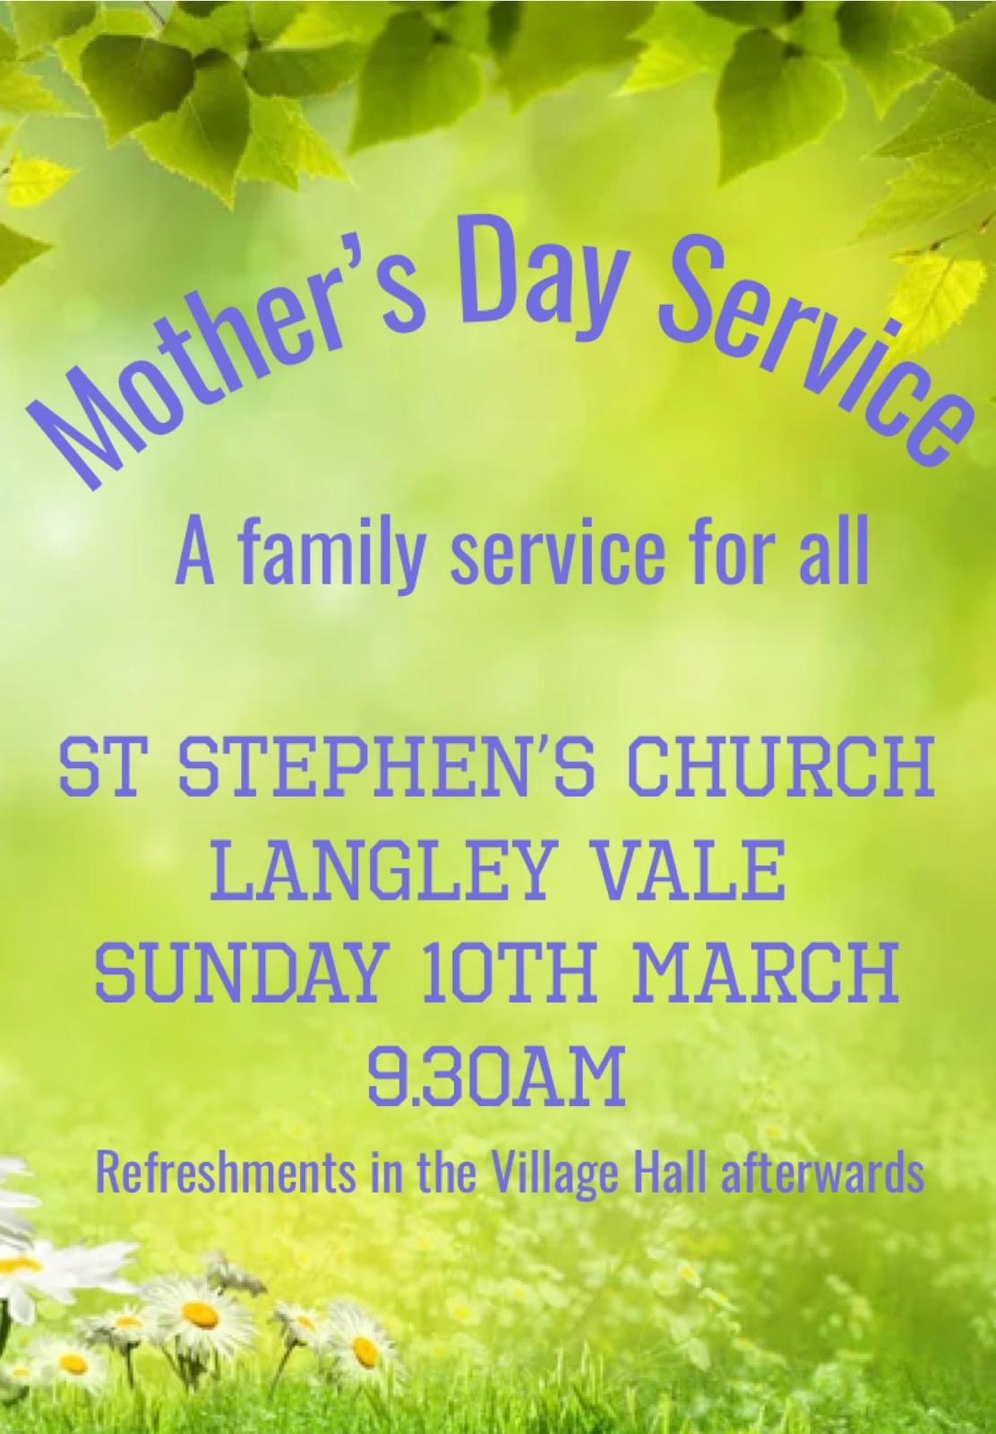

Submitting an item for the newsletter:
Please ensure that all items are emailed to the office marked
‘For Newsletter’ in the title the by
12pm on Wednesday, to be included in the newsletter
for that week.
Thank you.

Parish Office:
The parish office is open from 9.30am – 12.30pm every Monday, Wednesday and Friday.
Church House, Church Street, Epsom,
KT17 4PX Phone: 01372 722567
E-mail: office@stmartinsepsom.org
Website: www.stmartinsepsom.org

If you would like to be added to our mailing list so that you receive the newsletter and orders of service weekly, please email the parish office.
Please contact clergy and lay ministers via
the office.

Church Office Opening
The hours remain unchanged (9.30-12.30, Mon-Fri) but the Office will only be open to visitors and enquiries in person on a Monday, Wednesday and Friday. If you need to contact the Office on Tuesdays and Thursdays, please telephone (01372 722567), email office@stmartinsepsom.org or leave a note in the postbox outside Church House. Thank you.
David Eggett & Sarah Lutton

